Jenkins Freestyle Project:

To connect local repo code to commit some changes the code goes to the webserver ( Manual and Automation)

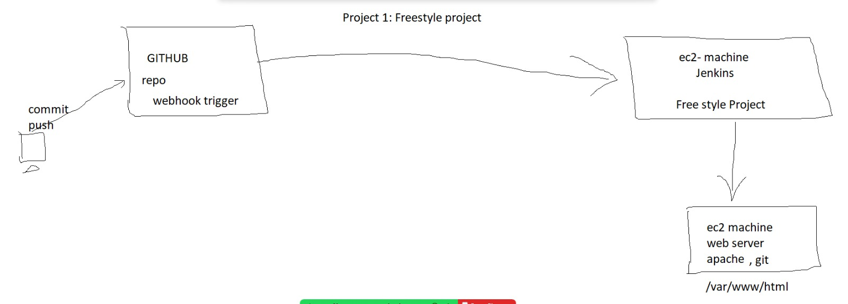



Jenkins server (ec2 machine):

1. git install (amazon linux)

Connect Jenkins ec2 machine to install Git using this commands

sudo su

yum install git -y

git --version



2. jenkins install

(<https://www.jenkins.io/doc/book/installing/linux/#red-hat-centos>)

Commands

sudo wget -O /etc/yum.repos.d/jenkins.repo \

<https://pkg.jenkins.io/redhat-stable/jenkins.repo>

sudo rpm --import https://pkg.jenkins.io/redhat-stable/jenkins.io-2023.key

sudo yum upgrade

sudo yum install fontconfig java-17 -y

sudo yum install jenkins -y

sudo systemctl daemon-reload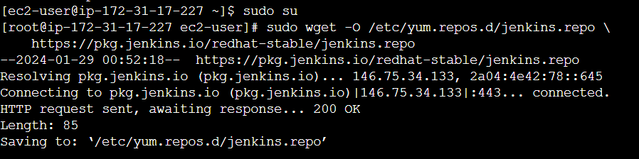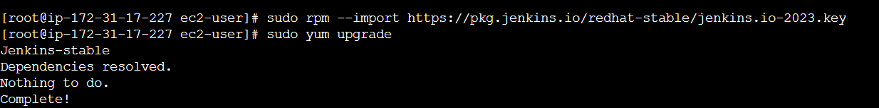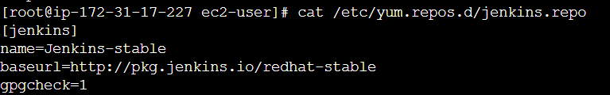 

3. jenkins start

systemctl enable jenkins

systemctl start jenkins

systemctl status jenkins



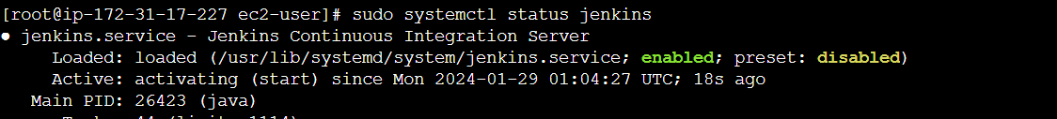

4. inbound rules 8080 add

To the Security group of jenkins ec2 machine

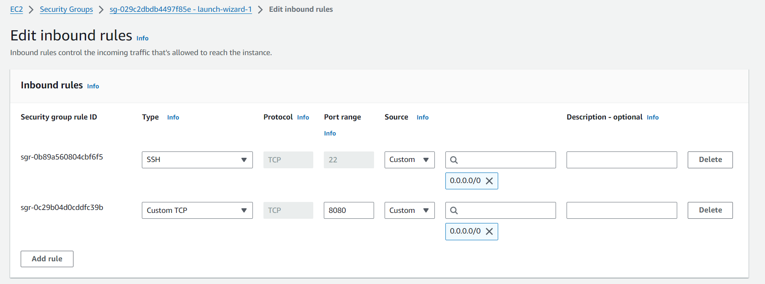

5.key generate (jenkins) login as jenkins user and generate a key   
Switch the Jenkins user with the below command

Command: **sudo su -s /bin/bash jenkins**



bash-4.2$ **ssh-keygen -t rsa**

id_rsa, id_rsa.pub

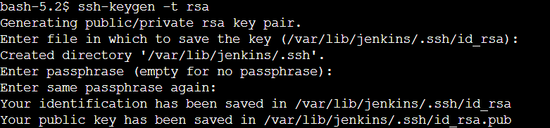

Jenkins UI:

6.ipaddress:8080 (Jenkins server public ip address :8080)

Password file stored on the server

cat /var/lib/jenkins/secrets/initialAdminPassword



7.password enter

8.configuration (username and password plugins install)

Then continue to the Next page

Click Installed to Suggested Plugins

**Jenkins Dashboard**

Click to Manage Jenkins -> Manage plugins

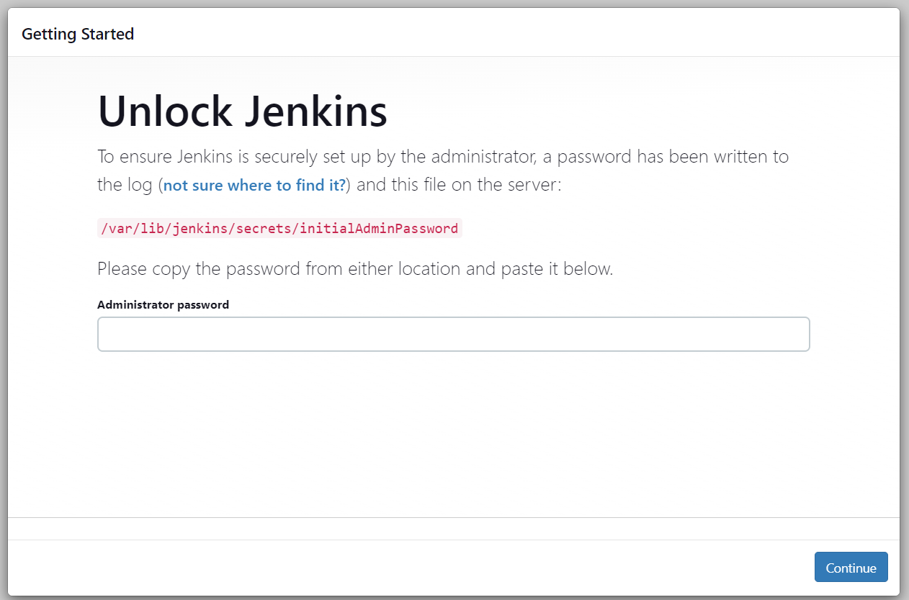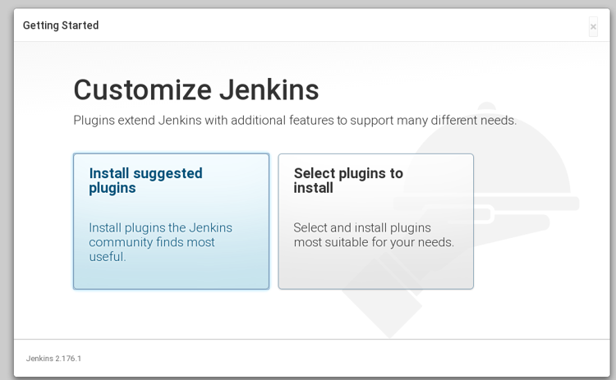

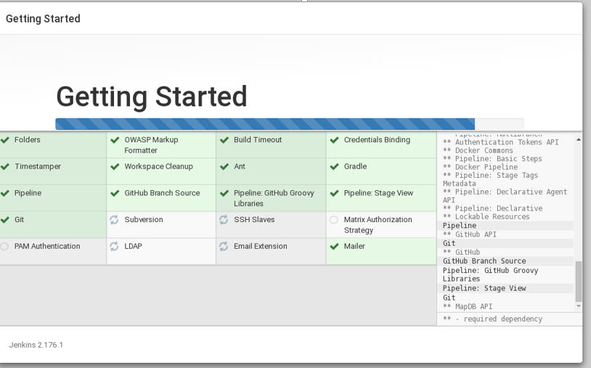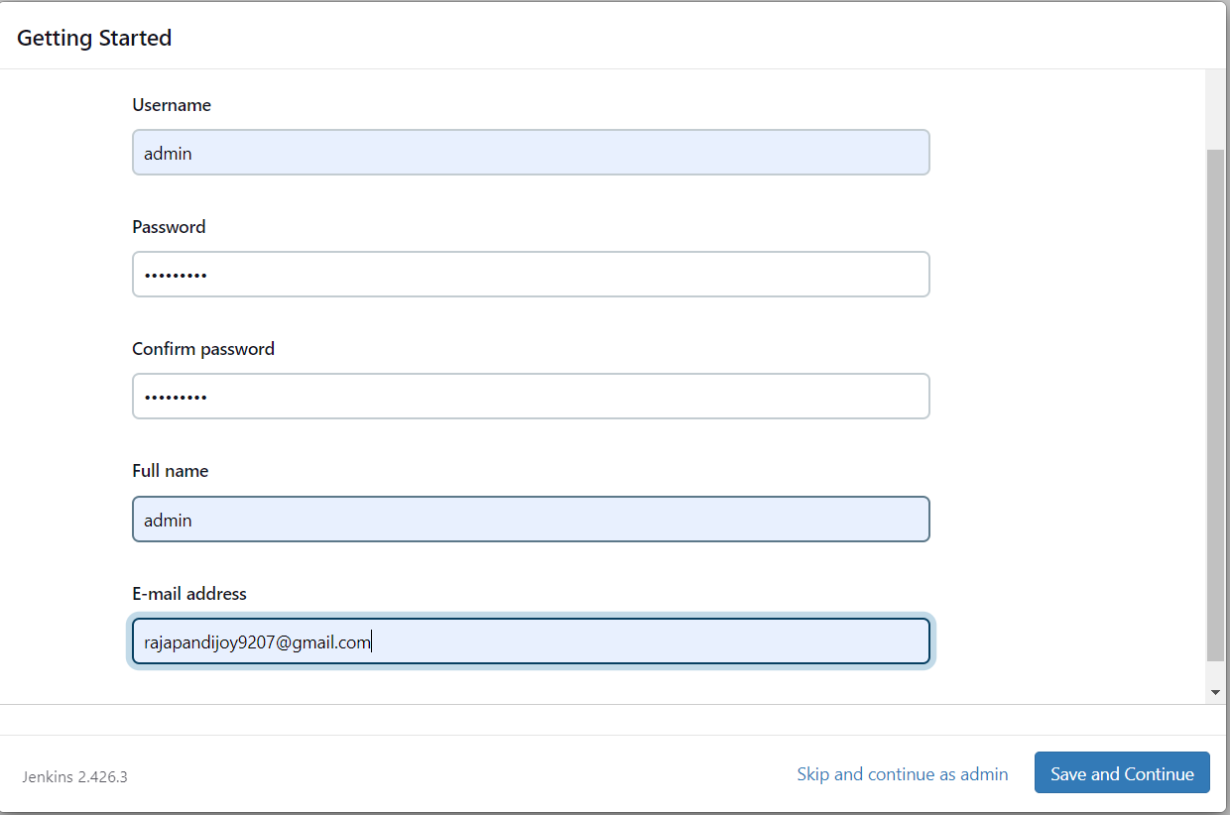

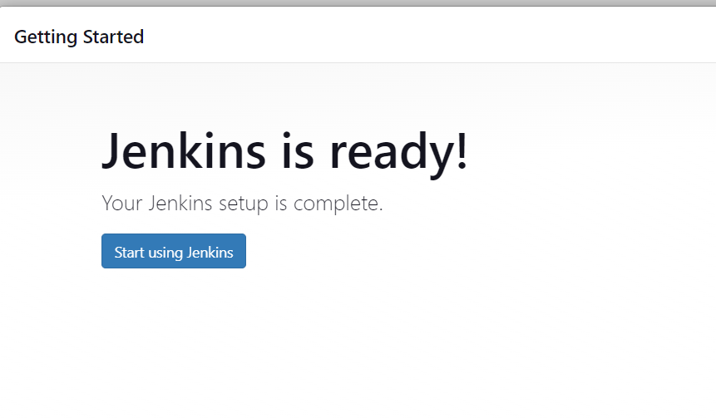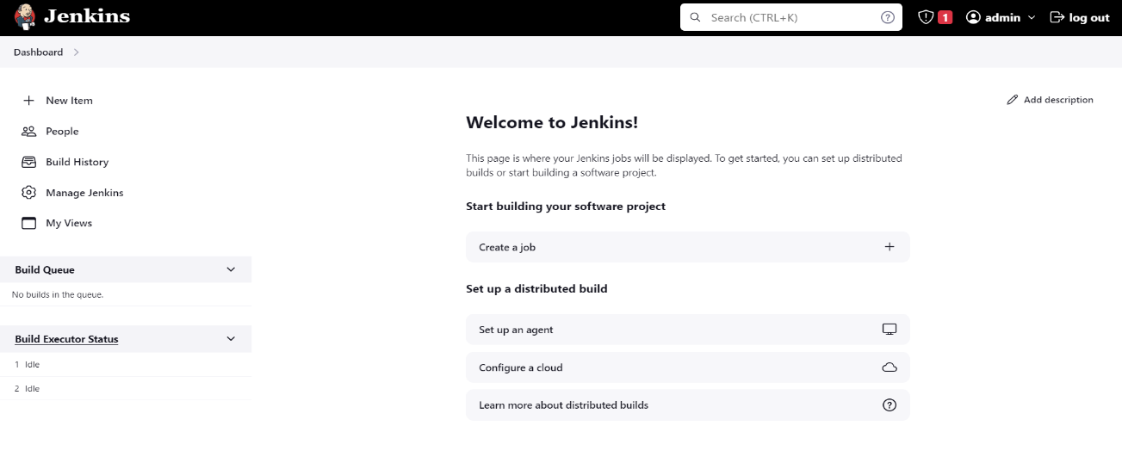

9.dashboard--> manage jenkins -- > plugins --> available plugins→ search( publish over ssh , git and github([GitHub Integration](https://plugins.jenkins.io/github-pullrequest),[GitHub Authentication](https://plugins.jenkins.io/github-oauth))

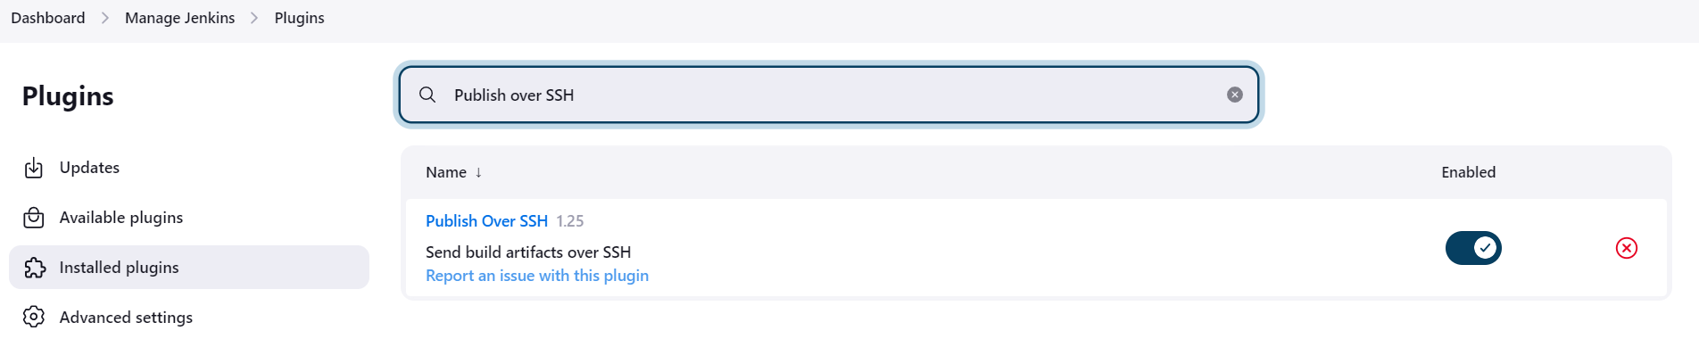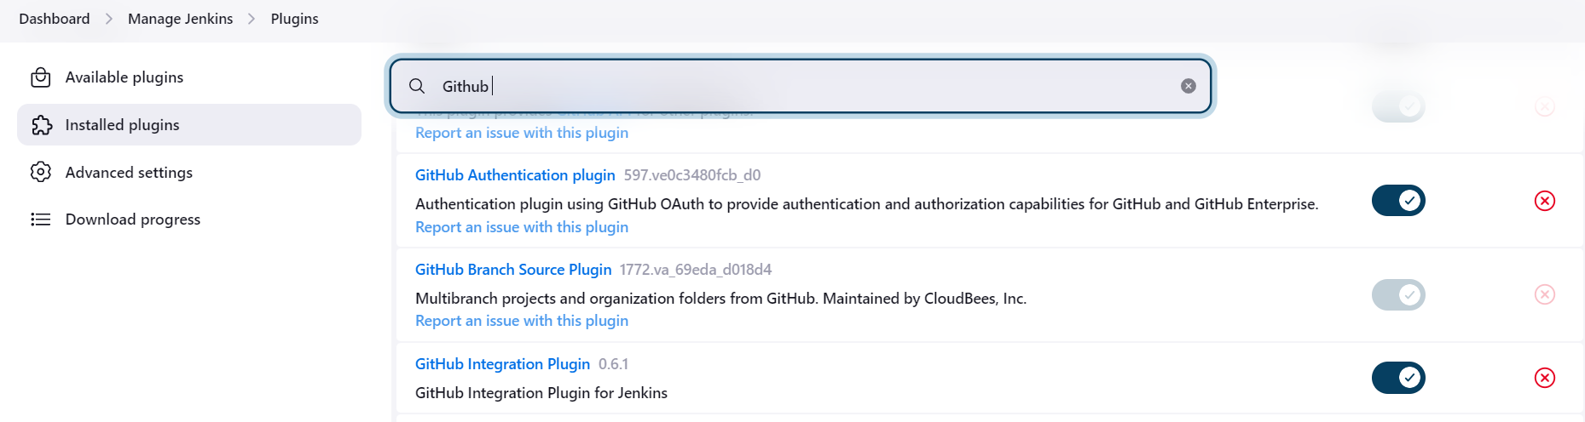

webserver server ((ec2)): ( Another ec2 machine using amazon linux)

10. git installation

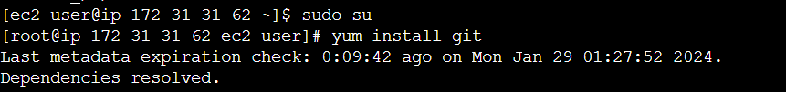

11./etc/ssh/sshd_config -- > need to enable the PubkeyAuthentication yes , PasswordAuthentication no --> restart the sshd service

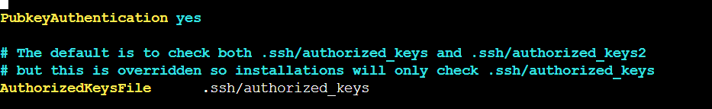

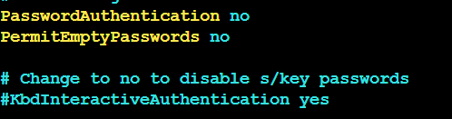

12. user creation, password set

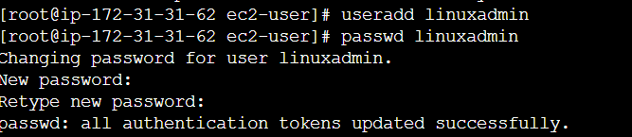

13. login as user

14.key generate (username)

id_rsa, id_rsa.pub

**ssh-keygen -t rsa**

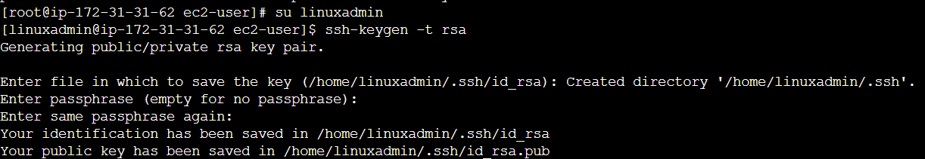

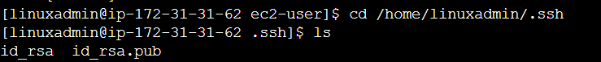

15. /home/username/.ssh/ --> Create the file with the below name authorized_keys --> Add the jenkins user's public key and save it. 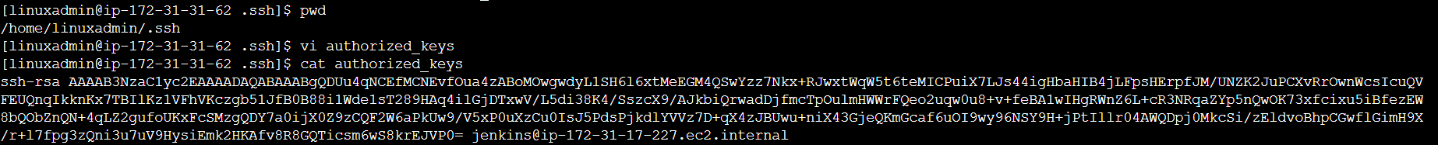

Give the permission 600 to the authorized_keys file

chmod 600 authorized_keys

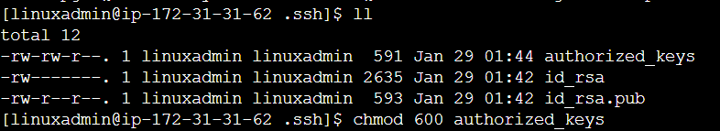

Jenkins UI:

16.Dashboard→ manage jenkins → system --> publish over ssh --> jenkins(private key), webserver’s ssh → ssh server (click add) ( username, hostname, userpassword)

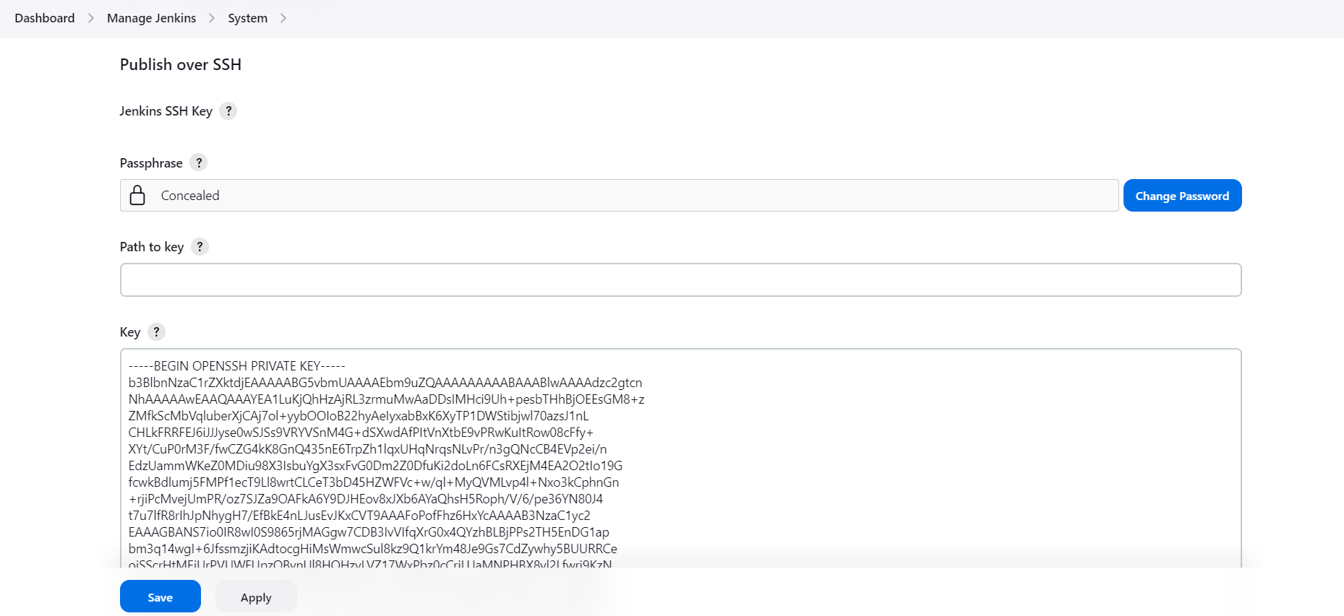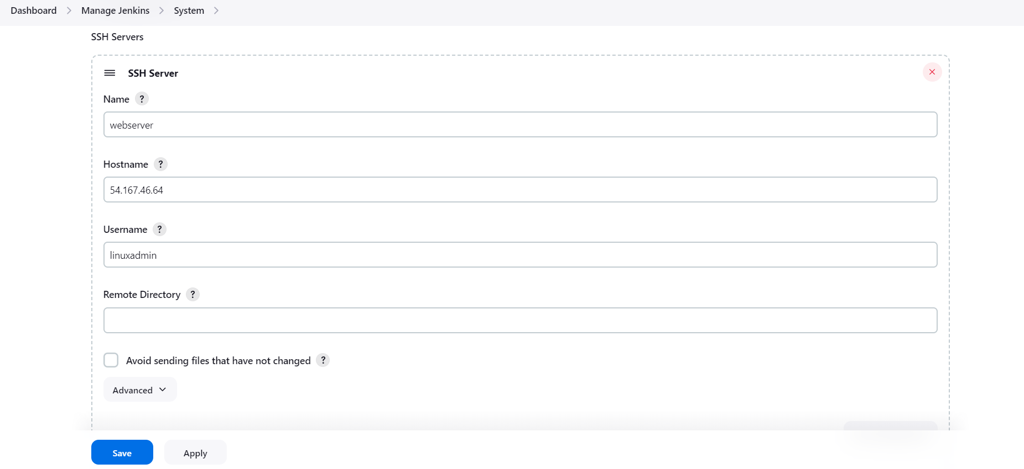

17.Dashboard→ manage jenkins --> credentails --> system --> globel cred --> add cred --> in kind choose → ssh username with private key --> scope (globel(jenkins node) → **add jenkins private key** --> click create to save

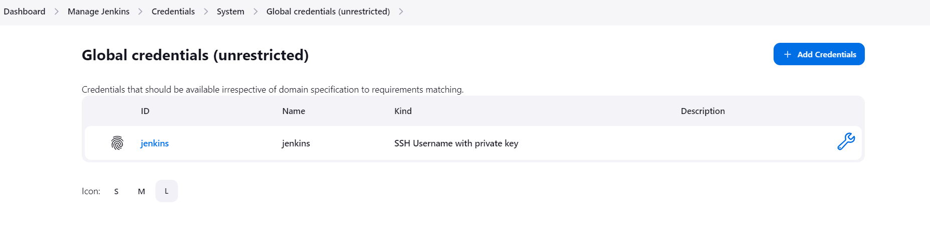Jenkins server (ec2 machine):

18. switch the jenkins user to check the connectivity between the jenkins server and webserver:

19. ssh webserver's username@hostip

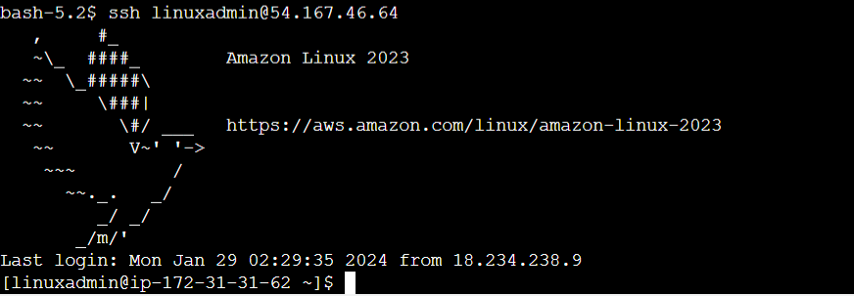

**Github:**

20.settings: SSH keys and gpg keys --> new ssh key --> save jenkins and webserver user public key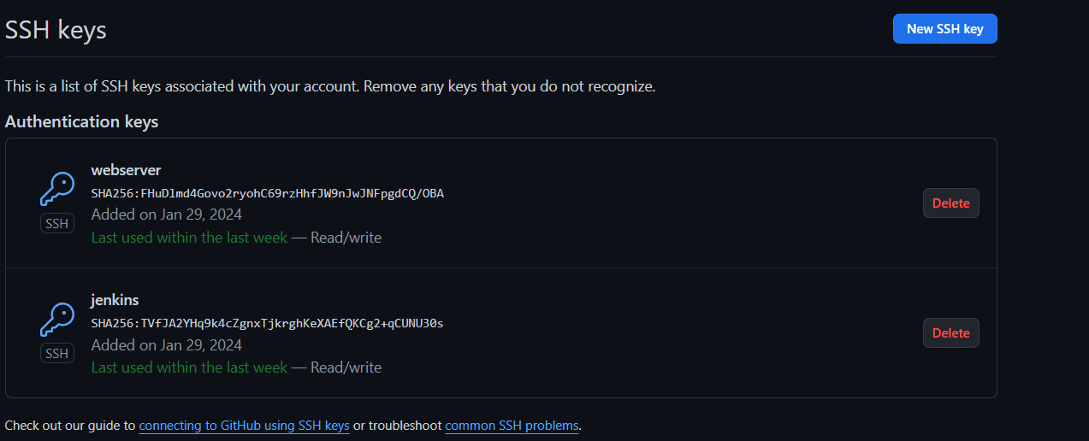

21. create the repo and add the any file inside the repo

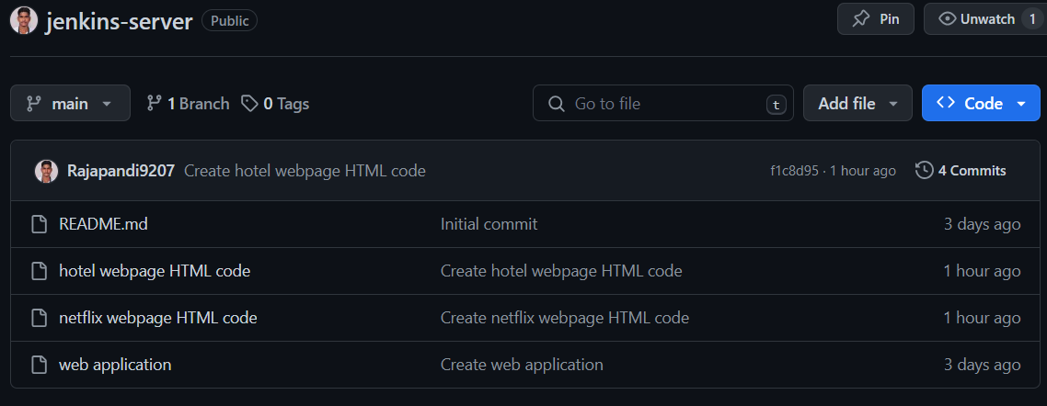

**webserver server ((ec2)):**

22. clone the repo to the webserver

Cloning as the username

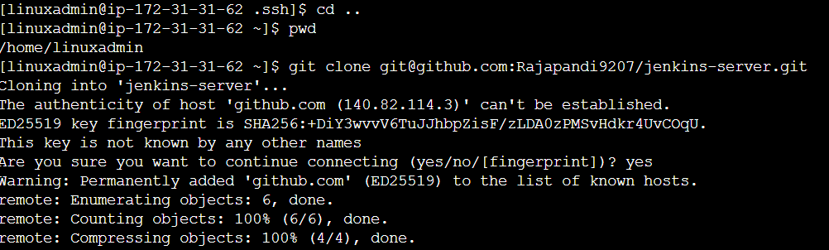

**Jenkins UI:**

23.creating the jenkins freestyle project --> dashboard --> click new item --> type any name and click freestyle project and click ok.

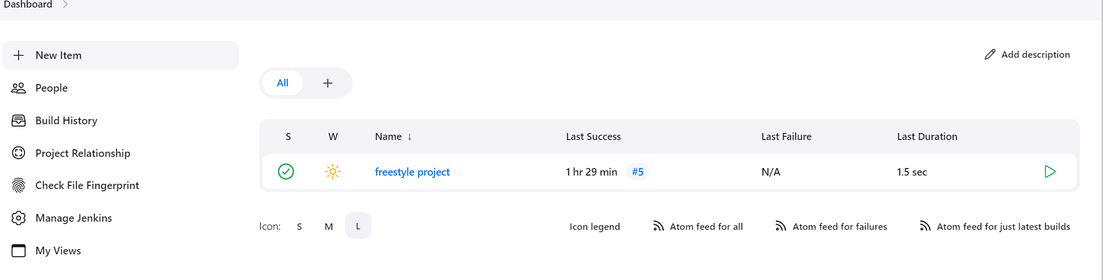

24.once freestyle project created need to configure the

soure code management : click --> git add the repo url

credentails--> choose the saved cred

branch --> need to choose main

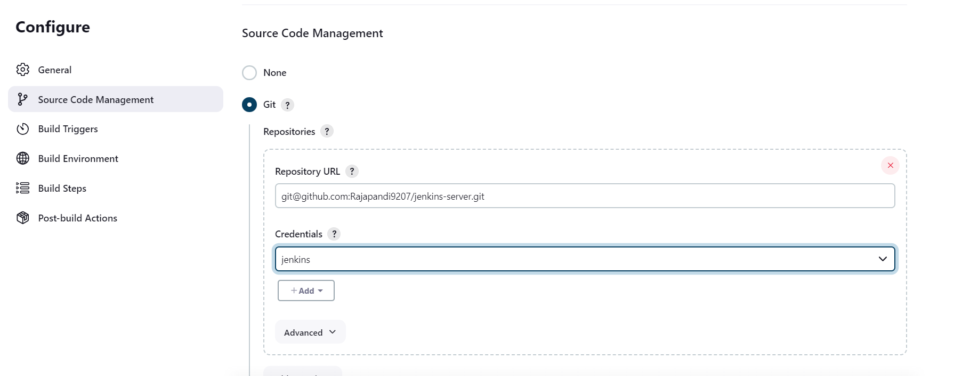

click --> GitHub hook trigger for GITScm polling

click build option and click execute shell option --> add the below script

ssh -tt linuxadmin@54.167.46.64 << EOF

cd /home/linuxadmin/jenkins-server

git pull origin main

ll -ls

exit

EOF

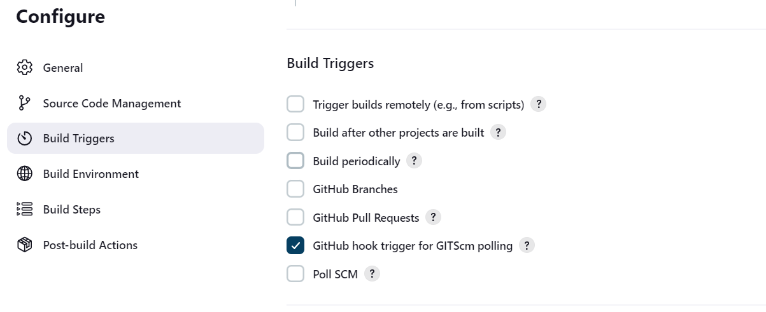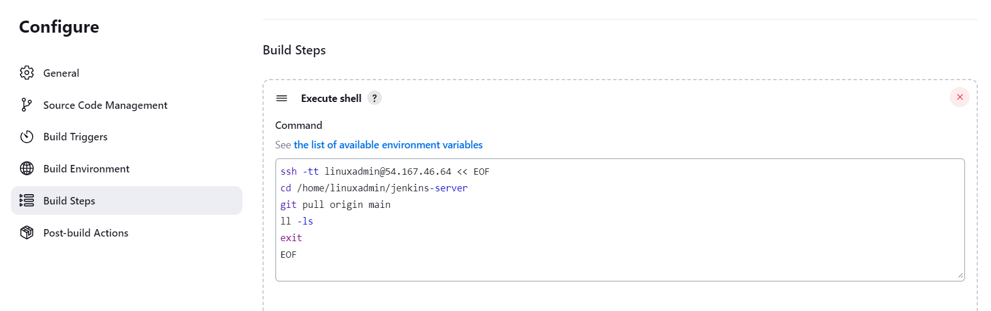

25.once completed save and click build now option.

Click the job --> click Build Now to check the logs( Manual)

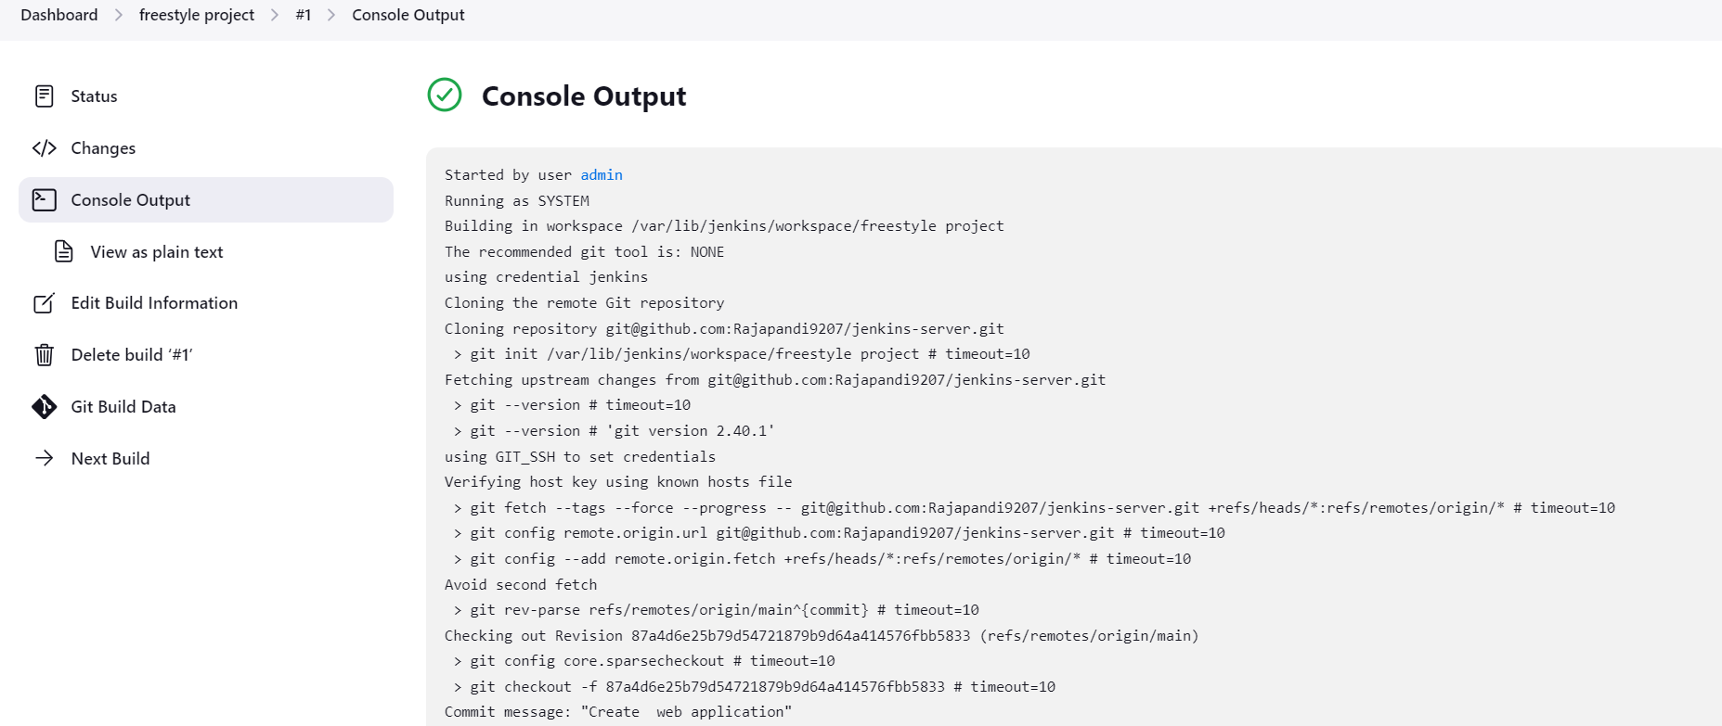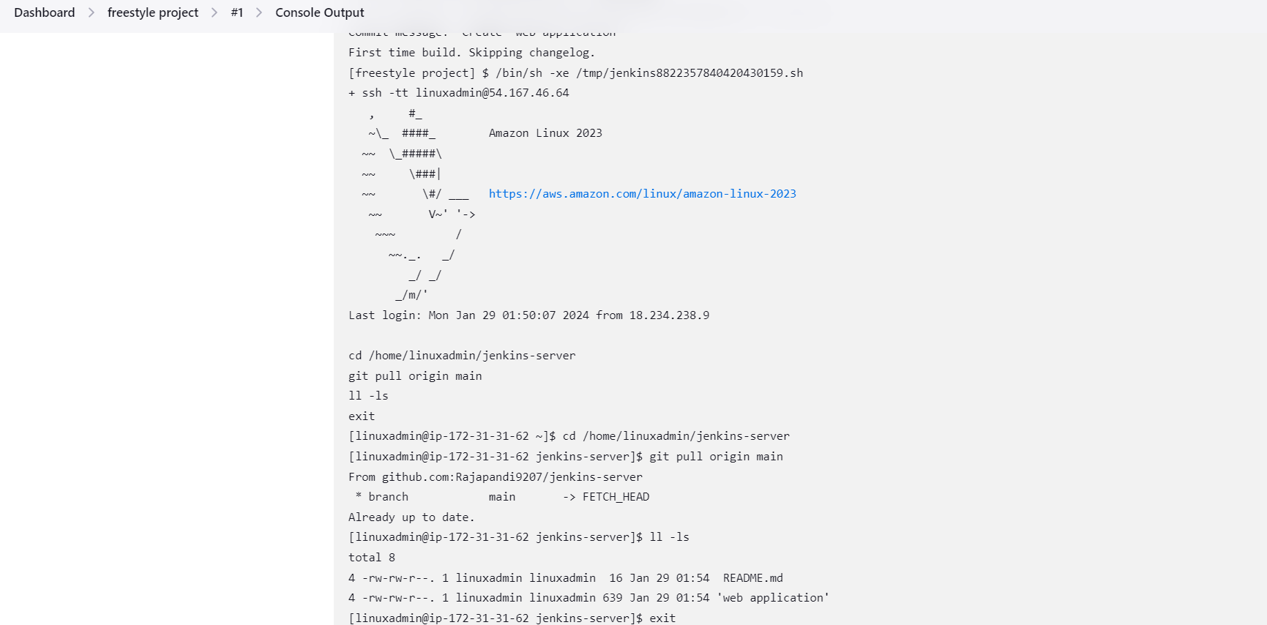

For Automate to use Webhook

Webhook

Github --> Repo --> Repo setting --> Click Webhook --> add webhook

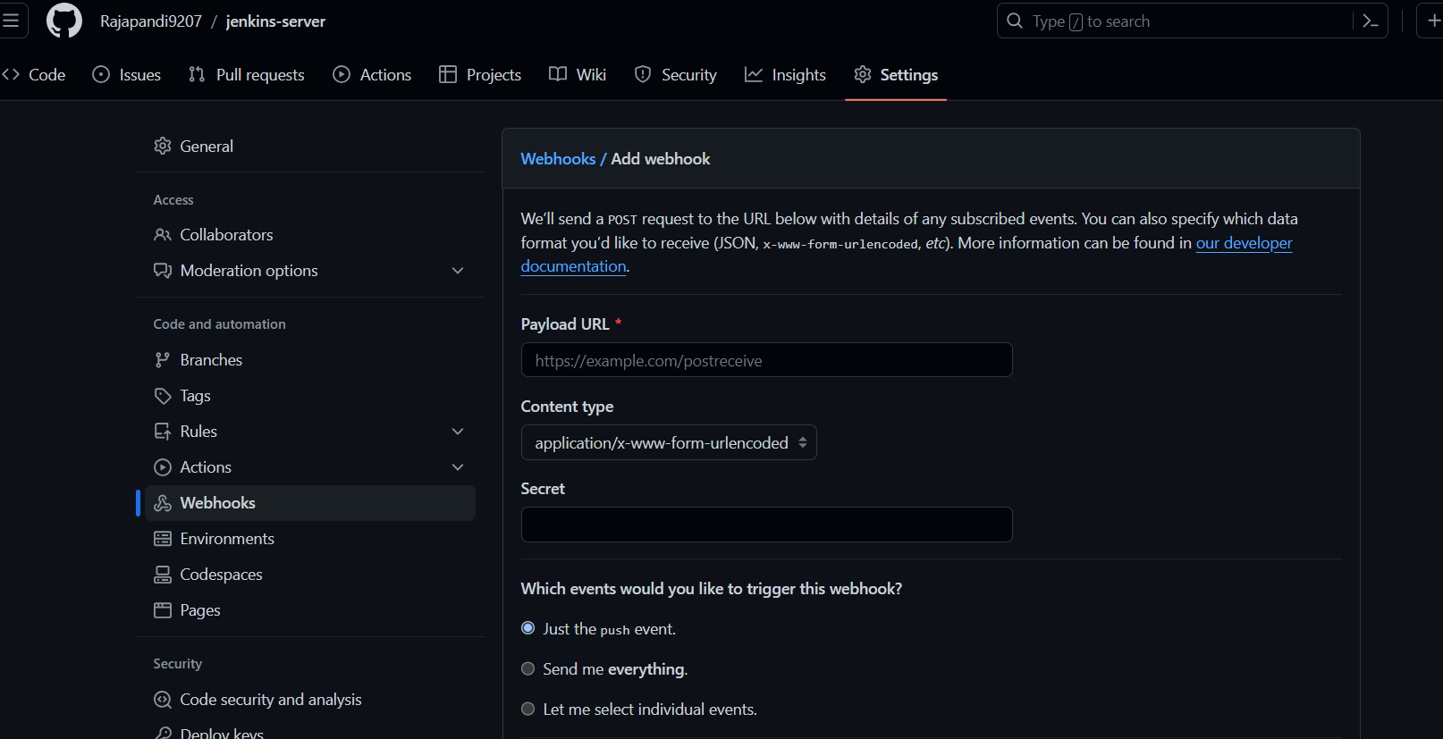

**Payload URL**

**Jenkins Url to add**

[**http://18.234.238.9:8080/**](http://18.234.238.9:8080/)

**Add Webhook**

